28th June 2013

Sanne Muurling
Kees Mandemakers

Data Description Zeeland census data 1811

I Source description

The census of 1811 was a census ordered by the French authorities. During French rule (1811-1813) they introduced a governmental system based on the French one, dividing the Netherlands in several Départements and appointing several préfects and sous-prefects. The French authorities obliged the mayors (called maires) to provide information about a wide range of matters, among which is the data about the composition of the population. In 1811 this data has been collected in several provinces, like Zeeland, Brabant and Overijssel. Not all censuses have survived and they have not all recorded information in the same way. For example, the 1811 census of Overijssel only records that part of the population that was 18 years and over, while Zeeland also records children. This allows for a more complete household reconstruction.

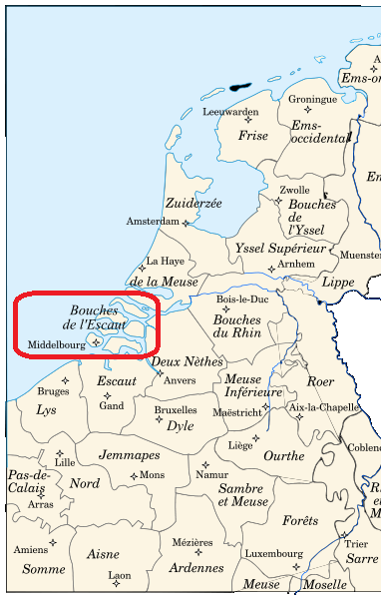
Although there was a standard form to be used by all municipalities in Zeeland, there are slight variations in what and in the ways in which information was recorded. For example, some municipalities record house numbers or explicit data about relationships of the person to the household, while others do not. This variance is also reflected in the database. Both for standardisation purposes and comparability we have flagged variables that we have constructed from the original data with an x.

The census data has been entered into the database by volunteers from the Zeeuws Archief, who were kind enough to provide us a copy. We have cross-checked the data in the database with the original censuses for accuracy and completeness. If necessary we corrected obvious mistakes and added missing data. Because multiple volunteers have worked on the digitization of the census, the database as we received it contained some inconsistencies in the way data was interpreted and documented. In some occasions we adopted these interpretations, but in principal we have chosen to record the data from the original censuses as they are.
Figure 1. The division of Holland during French Rule 1811-1813. Zeeland is marked red.

II List of municipalities

In the province of Zeeland the 1811 census of 74 municipalities has been digitized by the Zeeuws Archief. Our criterion for an initial core selection from the total set of data was completeness. The calculation of the completeness of the source per municipality was based on the number of recorded inhabitants (the number of records in the database) as a percentage of the total number of recorded inhabitants from that municipality’s 1830 census. We established a bottom percentage of 70%. This was based on the fact that population grow in Zeeland between 1810 and 1830 was on average about 25%. This resulted in a total of 26 municipalities, as seen below (table 1).

Table 1. First set of Zeeland’s 1811 census based on a comparison to the 1830 census
Municipality | No. of records | % of 1830 census
Arnemuiden | 860 | 0,71
Baarland en Bakendorp | 449 | 0,79
Biggekerke | 339 | 0,87
Borssele | 576 | 0,80
Driewegen en Coudorpe | 371 | 0,83
Goes | 4351 | 0,87
Heinkenszand | 943 | 0,76
Hoedekenskerke | 641 | 0,90
Kapelle en Biezelinge | 900 | 0,75
Kleverskerke | 188 | 1,13
Kloetinge | 718 | 0,92
Kruiningen | 781 | 0,72
Nisse | 398 | 0,83
Oost-Souburg | 529 | 0,98
Oudelande | 340 | 0,79
Ovezande | 602 | 0,90
Schore en Vlake | 300 | 0,88
Serooskerke (Walcheren) | 741 | 0,93
's-Gravenpolder | 467 | 0,82
's-Heer Arendskerke | 1218 | 0,80
's-Heerenhoek | 484 | 0,74
Wemeldinge | 698 | 0,85
West-Souburg | 284 | 0,90
Wolphaartsdijk | 856 | 0,84
Yerseke | 580 | 0,78
Zoutelande | 423 | 0,84

To determine if municipalities should be distinguished as urban or rural, we first looked at the list of municipalities that -as ‘cities having a vote’ (stemgerechtigde steden)- received the right to appoint representatives in the Dutch Provincial States in 1814. Nine of Zeeland’s municipalities received this right: Zierikzee, Veere, Middelburg, Vlissingen, Goes, Sluis, Axel, Hulst and Tholen. We have cross-checked this with the categorization of urban and rural areas after 1849. Another (additional) criterion that is often used for this time is that the number of inhabitants is at least 2500. According to this understanding of urbanity, only one municipality in the sample can be distinguished as urban, i.e. Goes.

III Archival references

Table 3. Archival references of the first set of Zeeland’s 1811 censuses
Municipality | Archival reference
Arnemuiden | Archief prefectuur, arch.no. 5, inv.no. 363 (Zeeuws Archief)
Baarland en Bakendorp | Archief prefectuur, arch.no. 5, inv.no. 367 (Zeeuws Archief)
Biggekerke | Archief prefectuur, arch.no. 5, inv.no. 362 (Zeeuws Archief)
Borssele | Archief prefectuur, arch.no. 5, inv.no. 367 (Zeeuws Archief)
Driewegen en Coudorpe | Archief prefectuur, arch.no. 5, inv.no. 367 (Zeeuws Archief)
Goes | Archief van de stad Goes 1267-1927, inv.no. 1919 (Stadsarchief Goes)
Heinkenszand | Archief prefectuur, arch.no. 5, inv.no. 367 (Zeeuws Archief)
Hoedekenskerke | Archief prefectuur, arch.no. 5, inv.no. 364 (Zeeuws Archief)
Kapelle en Biezelinge | Archief prefectuur, arch.no. 5, inv.no. 364 (Zeeuws Archief)
Kleverskerke | Archief prefectuur, arch.no. 5, inv.no. 363 (Zeeuws Archief)
Kloetinge | Archief prefectuur, arch.no. 5, inv.no. 364 (Zeeuws Archief)
Kruiningen | Archief prefectuur, arch.no. 5, inv.no. 365 (Zeeuws Archief)
Nisse | Archief prefectuur, arch.no. 5, inv.no. 367 (Zeeuws Archief)
Oost-Souburg | Archief prefectuur, arch.no. 5, inv.no. 362 (Zeeuws Archief)
Oudelande | Archief prefectuur, arch.no. 5, inv.no. 367 (Zeeuws Archief)
Ovezande | Archief prefectuur, arch.no. 5, inv.no. 367 (Zeeuws Archief)
Schore en Vlake | Archief prefectuur, arch.no. 5, inv.no. 365 (Zeeuws Archief)
Serooskerke (Walcheren) | Archief prefectuur, arch.no. 5, inv.no. 363 (Zeeuws Archief)
's-Gravenpolder | Archief prefectuur, arch.no. 5, inv.no. 364 (Zeeuws Archief)
's-Heer Arendskerke | Archief prefectuur, arch.no. 5, inv.no. 367 (Zeeuws Archief)
's-Heerenhoek | Archief prefectuur, arch.no. 5, inv.no. 367 (Zeeuws Archief)
Wemeldinge | Archief prefectuur, arch.no. 5, inv.no. 364 (Zeeuws Archief)
West-Souburg | Archief prefectuur, arch.no. 5, inv.no. 362 (Zeeuws Archief)
Wolphaartsdijk | Archief prefectuur, arch.no. 5, inv.no. 364 (Zeeuws Archief)
Yerseke | Archief prefectuur, arch.no. 5, inv.no. 365 (Zeeuws Archief)
Zoutelande | Archief prefectuur, arch.no. 5, inv.no. 362 (Zeeuws Archief)

IV Variable description

The following table (table 4) comprises all variables included in the census tables. Distinctions between the original values in the census and our interpretations, standardizations and so on have been made through the names of the variables. Variables followed by the suffix ‘_o’ are original data, with the suffix ‘_x’ are interpreted ones and with the suffix ‘-f’ are indicating how we have interpreted some specific data.
In quite a lot of municipalities the column ‘occupation’ consisted not only of occupational titles, but also of relationships to the head of the household and/or civil status. Additionally, information about relationships and civil status were also included in between columns in the census. To keep things clear we made three separate variables with the suffix ‘_o’ for relation, civil status and occupation, although this does not mean that there were in fact always three columns in the specific census.
In some censuses there is also an original column ‘comments’. This is not always filled, but if it was filled it could be data concerning departure, death or military service. We have also made separate variables to capture this kind of information with the suffix ‘_o’. In the source these comments were sometimes written in French and sometimes in Dutch, which is why the database currently records comments in both languages.
The census of 1811 was a pursuit of the French rulers. This means that in the original source, all data is written in French (except comments, which were sometimes added in Dutch). This is reflected in the occupational titles as well as civil status and relationships. In our database we want to capture the data as it is in the original census. However, although the volunteers of the Zeeuws Archief have generally recorded the original French occupational titles, they have translated some occupations into Dutch.
All Dutch municipalities are code with the so-called ‘Amsterdam-code’, which is the historical standard code for all Dutch municipalities existing from the 1st of January 1812 onwards (Ad van der Meer & Onno Boonstra, Repertorium van Nederlandse gemeenten 1812-2006 (DANS The Hague 2006). The latlon-references were provided by Nies Huijsmans (LIACS, Leiden Institute of Advanced Computer Science). ‘Unknown’ if a place or province or country could not be standardized.

Table 4. Variable description
Variable | Explanation
Id_sequence_x | Unique identifier; the sequence established by this code is identical to the sequence in the census.
Municipality_o | The municipality of the census.
Municipality_Adam_code | Amsterdam code for the municipality of the census
Municipality_lat | Latitude of centre of the municipality of the census (two digits)
Municipality_lon | Longitude of centre of the municipality of the census (two digits)
Province_x | The province to which the municipality belongs.
Country_x | The country to which the municipality belongs.
Urban_Rural_x | Urban or rural character of the municipality
 | Rural | Only Goes is considered as urban, for more information see the description of the sample.
 | Urban
Year_census_o | Year of the census.
Page_no_o | Page number of the person in the census.
District_no_o | The number of the district as taken from the census (not always included in the source).
House_no_o | House number of the dwelling.
Id_household_x | Household numbers as constructed according to the way the households are indicated in the source and the rules that have been used to distinguish different households as stated respectively in the following variables Household_source_f and Household_f. The numbering is unique per municipality.
Household_source_f | Flag assigned for how the households are distinguished (or not) in the source.
 | 1 | Persons are sequentially recorded in households, distinguished by house numbers and relationships and/or marital status which are explicitly included in the census.
 | 2 | Persons are sequentially recorded in households, distinguished by house numbers. No explicit relationships are distinguished in the census.
 | 3 | Persons are sequentially recorded in households, not distinguished by house numbers but are distinguished by defined relationships and/or marital status.
 | 4 | Persons are sequentially recorded in households, not distinguished by house number or defined relationship or marital status.
 | 5 | No explicit ordering in households to be discerned (e.g. in case of alphabetic ordering of the individuals).
Household_f | Flag assigned for the solution how households are determined (for the specification of the rules constructing the household identifier see appendix I):
 | 1 | Households are distinguished by explicitly given internal relationships.
 | 2 | Households are distinguished by house number
 | 3 | Households are distinguished by applying rules for household determination, rule 3.2. -3.6
 | 4 | Households are distinguished as an institution because of rule 3.7.1 – 3.7.3
Name_last_o | The surname of the individual as given by the source.
Name_prefix_o | The prefix of the individual as given by the source.
Name_first_o | The first name of the individual as given by the source.
Name_addition_o | Additional information about the name
Religion_o | The religion of the individual (only recorded in one municipality).
Civil_status_o | The civil status of the individual as given by the source.
Occupation_o | Occupation of the individual as given by the source. In the source this field is also used to record information about relationships or civil status, data which we have subdivided into Relation_x and Civil_status_o).
Occupation_standard_x | Standardized version of the occupation (in Dutch).
HISCO | The HISCO code assigned to the standardized occupation recorded in Occupation_standard_x. See, M.H.D. van Leeuwen, I. Maas and A. Miles, HISCO. Historical International Standard Classification of Occupations (Leuven 2002).
HISCO_status | The additional code assigned to add the dimension of status to the HISCO (not always given), see above.
OCCHISCO | HISCO code as used in the NAPP project
Relation_o | The relation of the individual within the household, if given by the source.
Relation_x | Constructed value of the relationship in the household (construction, because the relationship was not always included in the source, for rules see variable Relation_f).
 |  | Head
 |  | Wife
 |  | Child
 |  | Extended family
 |  | Co-resident
Relation_f | 32 | Head
 | 33 | Wife
 | 34 | Child
 | 35 | Extended family
 | 36 | Co-resident
 | 37 | Institution
Sex_x | The sex of an individual:
 |  | Male
 |  | Female
 |  | Undetermined
Sex_f | Flag assigned on how the sec of a person was determined
 | 1 | Sex of person is derived from the relationship in the household
 | 2 | Sex of person is derived from first name
 | 3 | Sex of person is explicitly recorded in the source
Age_o | The age of the individual as originally recorded in the census. Although the source records the age in French, the data in the database is translated into Dutch by the volunteers. Both years, parts of years and months are recorded in this field. We have separated this information to Age_year_x, Age_month_x and Age_weeks_x.  When the age is not specified in the source, this variable is left empty.
Age_year_x | The age of the individual when given as a year. Parts of years are recorded in years and months (in Age_month_x).
Age_month_x | The age of the individual distinguished as a number of months (used in the source for small children). When the number of months is higher than 12, the age is calculated in years (in Age_year_x) and months.  Children that are described as ‘younger than one years old’ have been standardized to being 6 months old.
Age_weeks_x | The age of the individual, generally a child, that is given in the source as a number of weeks. When the age is given in weeks it is not calculated to months, but is recorded as weeks only.
Age_days_x | The age of the individual, generally a child, that is given in the census as a number of days. When the age is given in days it is not calculated to weeks, but is recorded as days only.
Birth_place_o | The place of birth as given by the source. When this field is left blank in the source, we recorded this as ‘Unknown’.
Birth_place_x | Standardized place of birth.
Birth_municipality_x | Standardized name of municipality that includes location of place of birth
Birth_province_x | Standardized name of province that includes location of birth of birth
Birth_country_x | Standardized name of country that includes location of place of birth
Birth_place_Adam_code | Amsterdam code for municipality of birth
Birth_place_lat | Latitude of centre of the municipality of birth (two digits)
Birth_place_lon | Longitude of centre of the municipality of birth (two digits)
Arrival_date_o | The original date of arrival as it was originally recorded in the database. Several methods were used to record the arrival date. Most common is dd-mm-yyyy, mm-yyyy or yyyy, but other variations exist (like month name and year, or the number of years that the individual has lived in the municipality). This information is standardized into the fields of Arrival_day_x, Arrival_month_x and Arrival_year_x.
Arrival_day_x | The day the person arrived in the municipality, derived from Arrival_date_o.
Arrival_month_x | The month the person arrived in the municipality, derived from Arrival_date_o.
Arrival_year_x | The year the person arrived in the municipality, derived from Arrival_date_o.
Arrival_from_place_o | The place the person came from upon arrival.
Arrival_from_place_x | Standardized name of place person arrived from
Arrival_municipality_x | Standardized name of municipality that includes place person arrived from
Arrival_province_x | Standardized name of province that includes place person arrived from
Arrival_country_x | Standardized name of country that includes place person arrived from
Arrival_Adam_code | Amsterdam code for municipality person arrived from
Arrival_lat | Latitude of centre of municipality person arrived from (two digits)
Arrival_lon | Longitude of centre of municipality person arrived from (two digits)
Departure_day_o | The day the person departed from the municipality, if given by the source (originally from the comments column).
Departure_month_o | The month the person departed from the municipality, if given by the source (originally from the comments column).
Departure_year_o | The year the person departed from the municipality (originally from the comments column).
Departure_to_place_o | The place the person departed to.
Departure_to_place_x | Standardized place the person departure to
Departure_municipality_x | Standardized name of municipality that includes place person departed to
Departure_province_x | Standardized name of province that includes place person departed to
Departure_country_x | Standardized name of country that includes place person departed to
Departure_Adam_code | Amsterdam code for municipality person departed to
Departure_lat | Latitude of centre of municipality person departed to (two digits)
Departure_lon | Longitude of centre of municipality person departed to (two digits)
Deceased_o | Field to record the individual being deceased, in case this was recorded in the source (originally from the comments column).
Service_o | Additional information about the kind of (military) service the individual was in (originally from the comments column).
Source_info_x | The archive reference where the source can be found.

Appendix 1. Rules for making household variables

The Dutch 1811 censuses are rich historical sources that are documented per household. In Zeeland over half of these censuses have conveniently been organized by house numbers, which makes determining relationships relatively easy. Additionally, twelve of the Zeeland censuses contain explicit data about the relationship of the individual to the household (for example: wife, daughter, son, sister, nephew, orphan and so on).

Table 1. Information given by the Zeeland censuses of 1811 to distinguish household structures
None | Only house numbers | Only relationships | House numbers and relationships | Total
8 | 6 | 4 | 8 | 26

In order to distinguish household structures from the data we have constructed rules. These rules are based on the method described in Gruber, Scholz and Szoltysek article ‘Real and synthetic household populations and their analysis. An example of early historical census microdata (Rostock in 1819)’. Unlike the Rostock microdata, the Zeeland censuses are generally reported in a uniform household sequence of head, wife, children, servants, coresidents and so on, although variations do occur. To benefit the most from the reported structure we have expanded the set of rules to incorporate and capture this reported sequence if possible.

A household may consist of one or more persons. Special cases are institutions like hospitals, boarding schools or poor houses, which are also viewed as a(n institutional) household (see rule 3.7).

In determining households, page ordering is of no use because most of the censuses were filled from top to bottom. With special variables (flags) we indicate how we have constructed the household and the relationships.

I Sources with explicitly given house numbers
- Persons with the same house number are assumed to be in the same household. A house number was given in fourteen villages out of a total of 26 (including Goes). Distinguishing everyone on one house number as one household means that there is a risk that persons are seen as boarders while in fact they have their own entrance in the house. This may also lead to two families being grouped into one household.

II Sources without explicitly given house numbers
- In villages without explicitly given house numbers households have to be deduced from the composition of a group of persons. This presupposes that persons are included in the census register in order of a household sequence and that the special roles in the household may be distinguished (see rules 3.1 to 3.7). This has the consequence that boarders may be categorized as households on their own.

III. Rules to determine relationships in a household (and defining the limits of a household)

- Basics assumptions behind interpreting household composition:
  - In case relationships and/or marital status are made explicit, for example wife, son or daughter, we take this value instead of using a rule.
  - If head of households are not made explicit, they can be recognized by:
    - Being the first person in a sequence of numbered households (in case when the house numbers are given in the source);
    - Being a male over 18 years old and being recognized as part of a marriage (see rule 3.3);
    - Being over 18 years old and having children (younger persons with the same last name, in case of a female last names will differ, see rule 3.4) ;
    - Being a person over 36 years old listed first in a sequence not clearly related to the previous household and sharing the same last name as other following but younger persons in the source over 18 years of age (either their adult children or other relatives).
  - Marriage of 2 persons: The second person in the census household is assumed to be the wife of the head of the household in case the person is a female, be explicitly married or having a different last name than the head of the household (and should not be explicitly divorced or unmarried), be over 15 years old.
  - Children: Other persons are assumed to be children of the head of the household if they are explicitly referred to as child, daughter or son, and/or have the same last name as the potential father and have an age difference of at least 15 and at most 46 years with the potential mother (and 55 for a potential father by lacking a mother). When a widow is the head of the households, more than one person with the same (but different from the mother’s) last name in that household that have an age difference of at least 15 and at most 46 years with the potential mother are considered to be children as well.
  - Other related household members: In case persons with the same last name as the head of the household or their spouse differ less than 15 years of age or in case they are older than the head or their spouse they are supposed to be relatives if they have the same last name of the head or the wife of the head. The family of the relative is also assigned to the previous household.
  - Other non-related household members: Persons are assigned to the household when:
    - Their occupational title belongs to the list of occupational titles indicating co-residence (e.g. servant, apprentice, journeyman) and the person is unmarried;
    - The relationship to the household head is consistent with this occupation;
    - The occupational title is similar to the previous one, and the person is not married;
    - The person is unmarried and below the age of 20 years; The person is an unmarried woman below the age of 25 years;
    - The person is an unmarried woman between the ages of 20 and 39 years, and there is no occupational information about her.
    - The person is an unmarried or widowed women above the age of 40, and there is no occupational information about her and the relationship to the previous and next household is unclear (no recurring last name, no explicit information about relationships).
  - Institutions are recognized by
3.7.1 Having a head with typical occupations like ‘Boarding house holder’, ‘School teacher’, ‘Poor house father’ etc., followed by a series of unrelated last names.
3.7.2 Having a specific title in the address or name, indicating an institutional setting
3.7.3 Having a special place in the census book.

Appendix 2. Photographs of the variations of the Zeeland census 1811

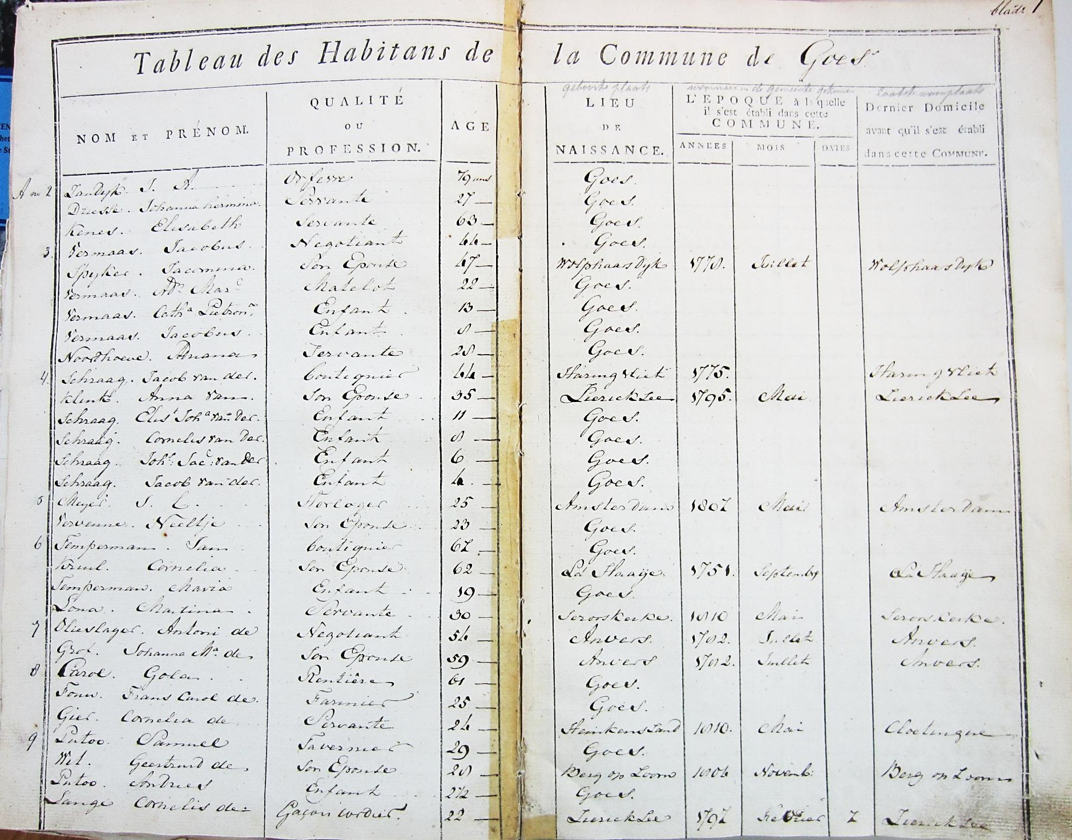
Figure 2. 1811 Census of Goes. Common form that includes house numbers and relationship data.

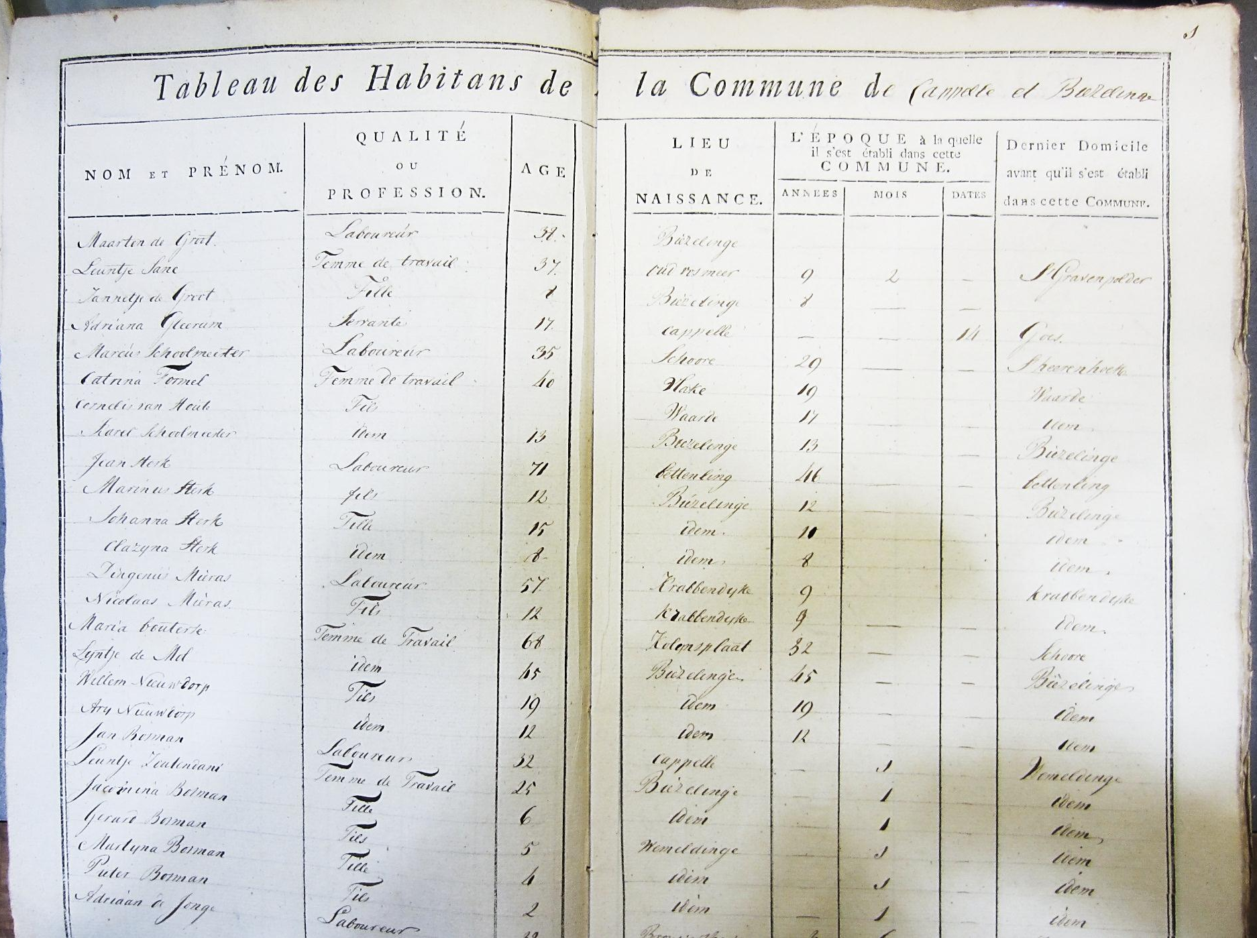
Figure 3. 1811 Census of Kapelle en Biezelinge. Common form that includes explicit relationships but without house numbers.

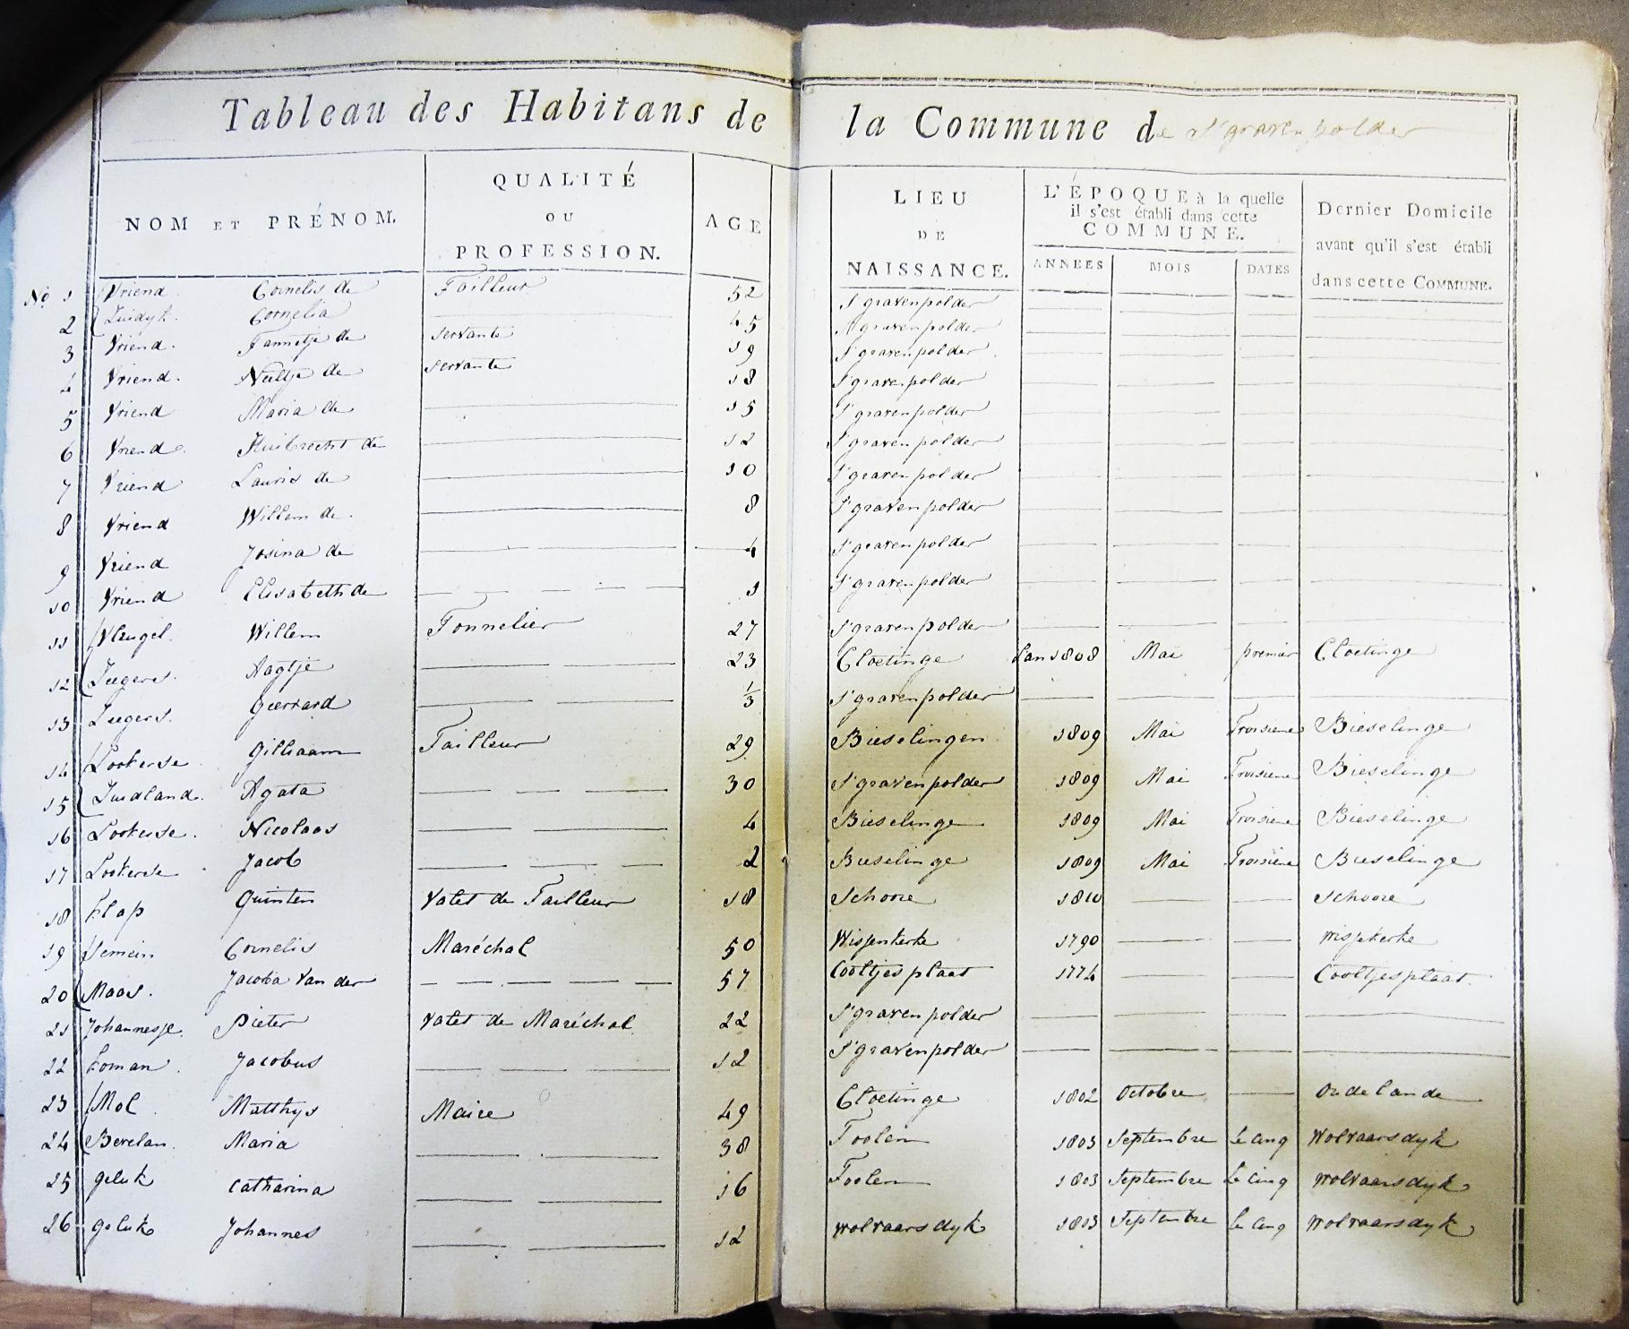
Figure 4. 1811 Census of 's-Gravenpolder. Form that does not distinguish house numbers or relationships.

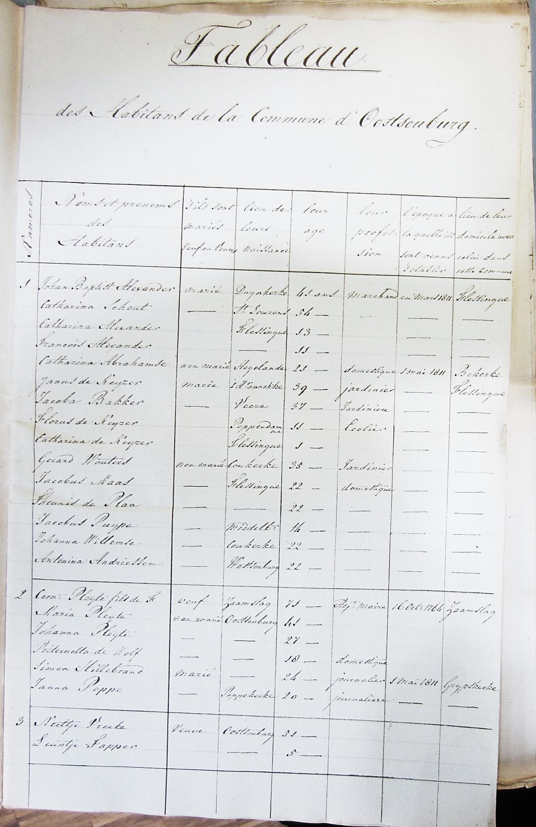
Figure 5. 1811 Census of Oost-Souburg. Form that includes civil status and house numbers.

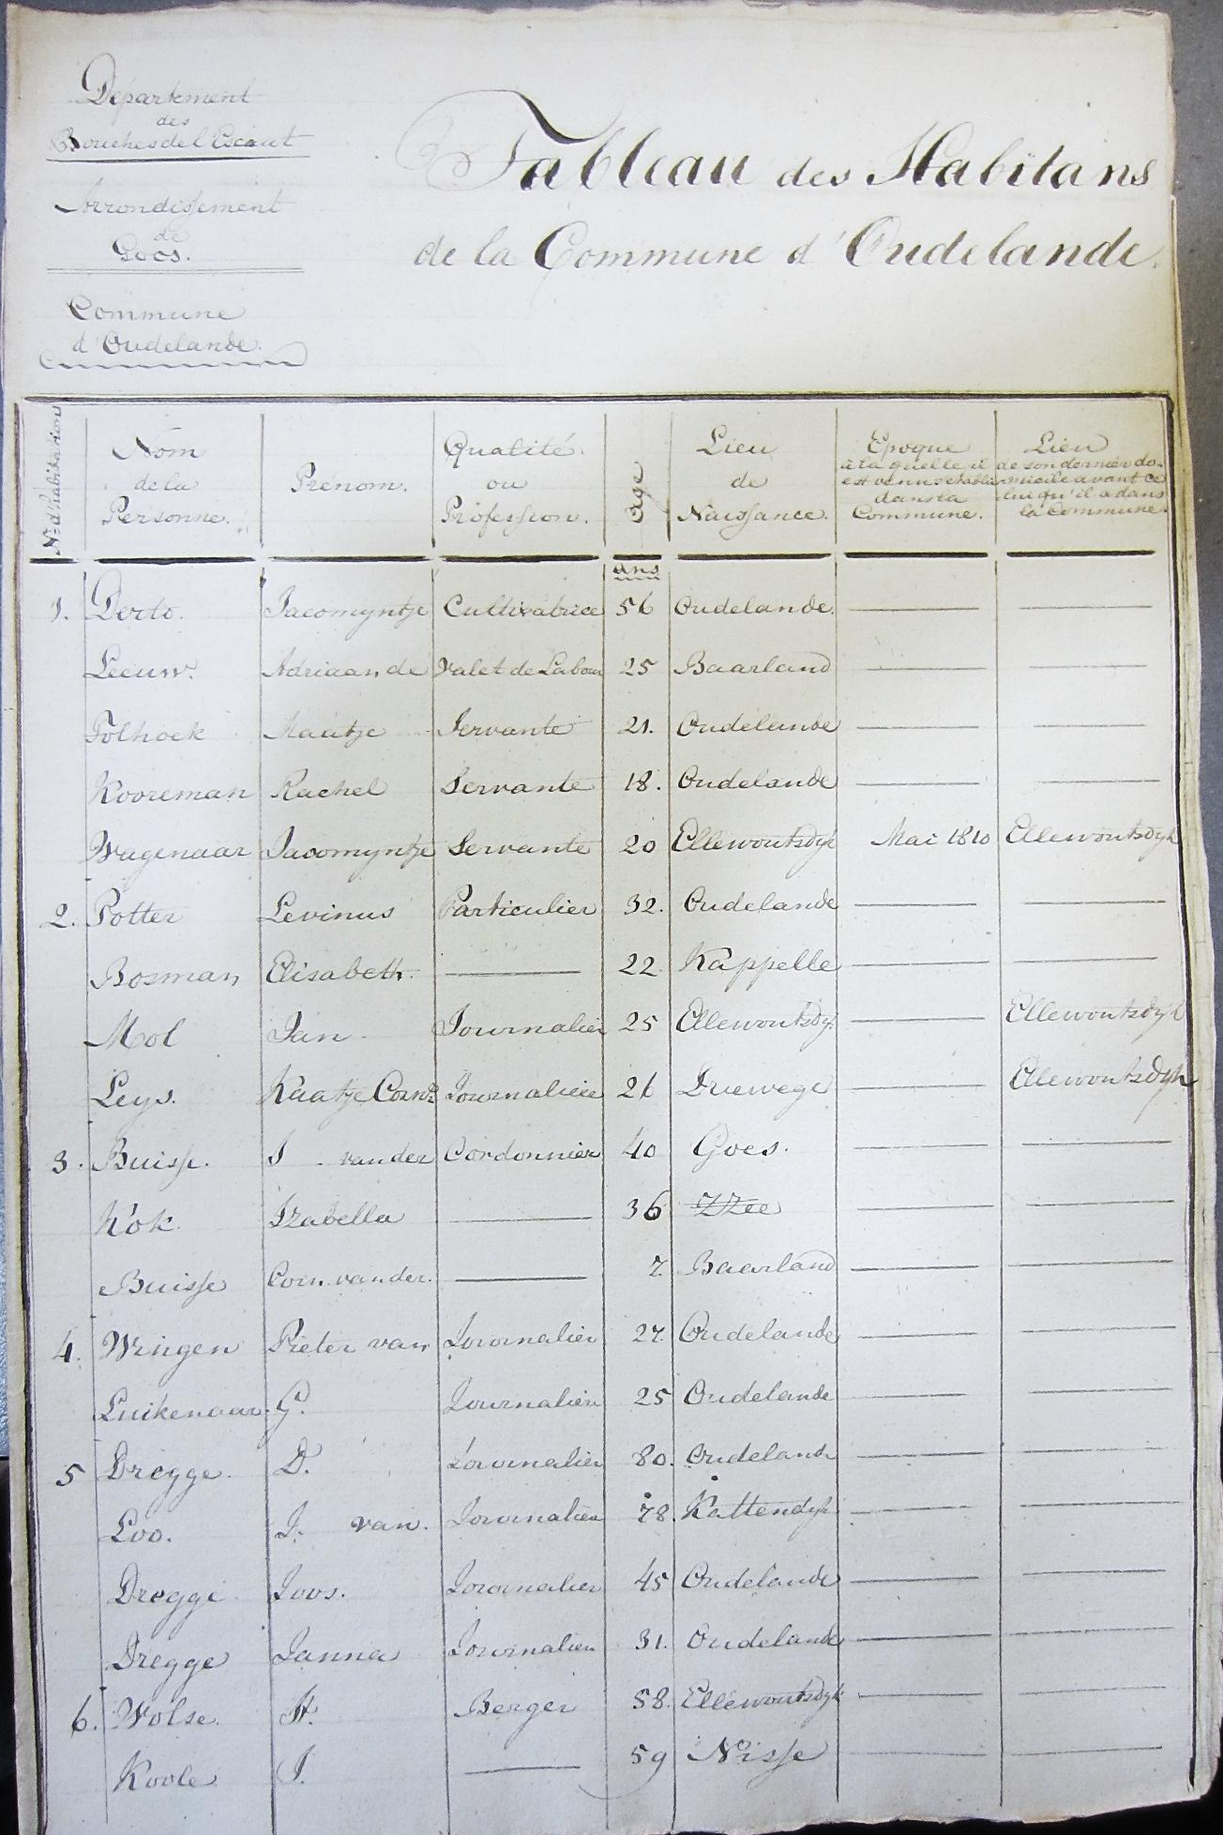
Figure 6. 1811 Census of Oudelande. Alternative common form that distinguishes house numbers but no relationships.

E.W. Hofstee, ‘Demografische ontwikkeling van de Noordelijke Nederlanden ca. 1800- ca. 1975’, in D.P. Blok (ed.), Algemene Geschiedenis der Nederlanden, volume X (Haarlem 1981), 64-65.
Reglement omtrent de samenstelling van de Staten der provincies, resp. het Landschap Drenthe (Koninklijk Besluit 6 April 1814). The entire list of municipalities that received this right: Groningen, Leeuwarden, Franeker, Dokkum, Harlingen, Sneek, Bolsward, IJlst, Sloten, Workum, Hindeloopen, Stavoren, Assen, Coevorden, Meppel, Zwolle, Kampen, Deventer, Hattem, Elburg, Harderwijk, Nijkerk, Zutphen, Lochem, Groenlo, Arnhem, Doesburg, Doetinchem, Wageningen, Nijmegen, Bommel (Zaltbommel), Tiel, Kuilenborg (Culemborg), Utrecht, Wijk, Rhenen, IJsselstein, Montfoort, Amersfoort, Weesp, Amsterdam, Monnickendam, Edam, Enkhuizen, Hoorn, Medemblik, Alkmaar, Purmerende, Zaandam, Haarlem, Leyden, Woerden, Gouda, ’s-Gravenhage, Delft, Schoonhoven, Schiedam, Maassluis, Brielle, Vlaardingen, Gorinchem, Dordrecht, Rotterdam, Zierikzee, Veere, Middelburg, Vlissingen, Goes, Sluis, Axel, Hulst, Tholen, Willemstad, Bergen op Zoom, Geertruidenberg, Oosterhout, Breda, Tilburg, Heusden, Grave, ’s-Hertogenbosch, Helmond, Eindhoven, Venlo en Maastricht. Helmond lost its right in 1815. In 1818 Weert was added.
M.C. Deurloo and G.A. Hoekveld, ‘The population growth of the urban municipalities in the Netherlands between 1849 and 1970, with particular reference to the period 1899-1930’, in: H. Schmal (ed.), Patterns of European urbanization since 1500 (London 1981)249-283.
P. Brusse, Gevallen stad. Stedelijke netwerken en het platteland. Zeeland 1750-1850 (Utrecht 2010) 25-26.
S. Gruber, R.D. Scholz and M. Szoltysek, ‘Real and synthetic household populations and their analysis. An example of early historical census microdata (Rostock in 1819)’, Historical Methods 44:2 (2011) 107-113.

